SFSS Championships 17th January 2026
Order & Timing of Events at Graves Park

Event No. | Age Group | Laps | Approx distance | Time
1 | Y7 Girls | 1 Large | 1850m | 09.40
2 | Y7 Boys | 1 Large | 1850m | 09.50 approx
3 | Y8/9 Girls | 1 Medium, 1 Large | 3300m | 10.00  approx
4 | Y8/9 Boys | 1 Medium, 1 Large | 3300m | 10.15  approx
5 | Y10/11 Girls & Y12/13 Girls | 2 Large  2 Large | 3700m  3700m | 10.30  approx
6 | Y10/11 Boys & Y12/13 Boys | 3 Medium  3 Large | 4500m  5500m | 10:45  approx

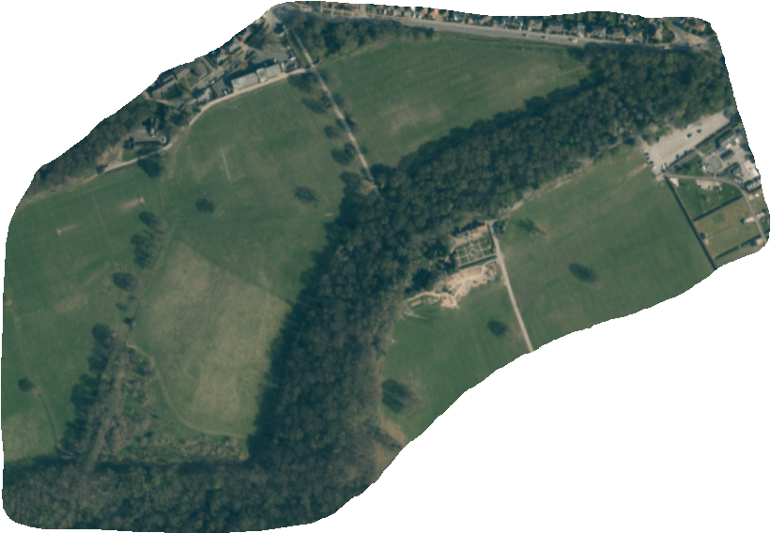
Large lap—YELLOW route

Start—A—B—C—D—E—F—G—H—I—J

Medium Lap—YELLOW to F, then RED to I

Start—A—B—C—D—E—F—I—J
I
E
B
G
H
D
J
C
F
Finish
Start
A
Start and finish in front of the pavilion.

